**Aim:**

To analyze and synthesize a particular signal using a Fourier series.

**Documentation:**

* **Fourier Series:** A Fourier series is a way of representing a periodic function as a (possibly infinite) sum of sine and cosine functions or exponential functions. These functions are harmonically related.
* **Properties:** The Fourier series coefficients of a signal are linear and obey time reversal. Conjugation of the signal in time causes negated conjugation in frequency. Shifting in time causes multiplication by an imaginary exponential in frequency and vice versa.
* **Practical Convolution:** In reality, the convolute of two signals can be calculated by taking the integral of one signal after shifting and reversing one.
* **Note:** Fourier Series is also applicable to discrete functions.

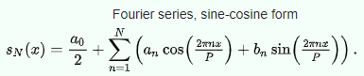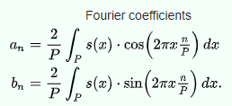

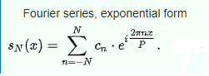

**Program Listing:**

* **Sine-Cosine**

syms x

syms n

r = 3

c = 2

y = rectangularPulse(0,1,x);

a0 = (1/2)*int(y,x,0,2);

an = (2/2)*int(y*cos(2*pi*n*x/2),0,2);

bn = (2/2)*int(y*sin(2*pi*n*x/2),0,2);

t = 50;

z = a0 + symsum(an*cos(2*pi*n*x/2)+bn*sin(2*pi*n*x/2),n,1,t);

subplot(r,c,1)

fplot(y,[-0.5 1.5])

title('Pulse')

xlabel('Time')

ylabel('Amplitude')

subplot(r,c,2)

fplot(z,[-0.5 1.5])

hold

fplot(y,[-0.5 1.5])

title('Pulse and Approximation')

xlabel('Time')

ylabel('Amplitude')

subplot(r,c,3)

fplot(n,an)

xlabel('n')

ylabel('an')

title('an vs n')

subplot(r,c,4)

fplot(n,bn)

xlabel('n')

ylabel('bn')

title('bn vs n')

subplot(r,c,5)

fplot(n,phase(an))

xlabel('n')

ylabel('phase of an')

title('phase of an vs n')

subplot(r,c,6)

fplot(n,phase(bn),[-10 10],'sr')

xlabel('n')

ylabel('phase of bn')

title('phase of bn vs n')

* **Exponential**

syms x

syms n

r = 3;

c = 1;

y = rectangularPulse(0,1,x);

an = (1/2)* int(y*exp(-i*2*pi*n*x/2),0,2);

a0 = (1/2) * int((y),0,2)

pr = 25;

z = a0 + symsum(an*exp(i*2*pi*n*x/2),n,-pr,-1) + symsum(an*exp(i*2*pi*n*x/2),n,1,pr);

subplot(r,c,1)

fplot(z,[-0.5 1.5])

hold

fplot(y,[-0.5 1.5])

title('Pulse and Approximation')

xlabel('Time')

ylabel('Amplitude')

subplot(r,c,2)

fplot(n,abs(an),'xr')

xlabel('n')

ylabel('an')

title('an vs n')

subplot(r,c,3)

fplot(n,phase(an))

xlabel('n')

ylabel('phase of an')

title('phase of an vs n')

**Results –**

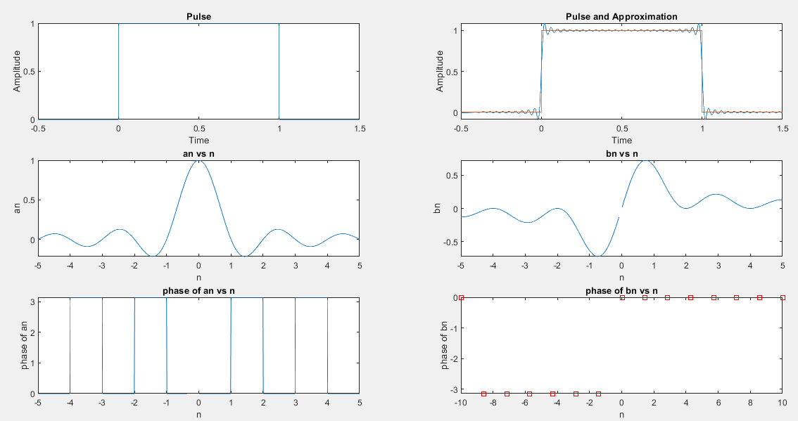

Output for Sine-Cosine version

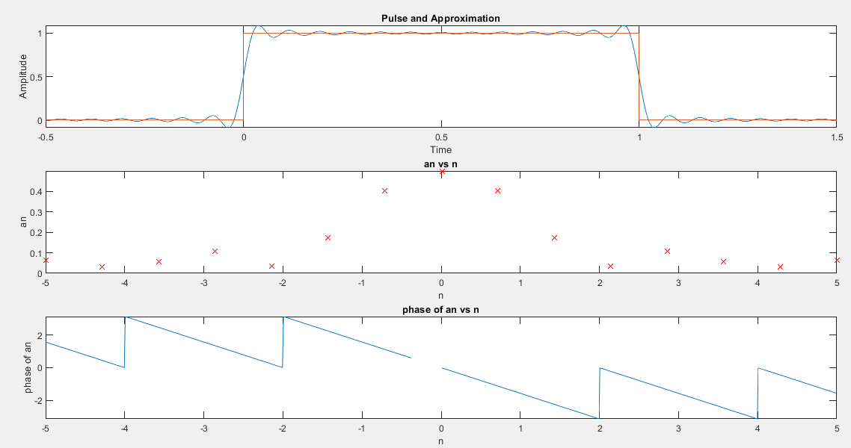

Output for Exponential version

**Conclusions –**

* Fourier Series examination is a powerful mathematical tool with a multitude of applications in various fields, especially signals and systems.
* It can be used to analyze a signal in both frequency and time domains, and to simplify system operation by removing the need to apply convolution operations.
* Practically, it is used to create difficult signals using a linear combination of sines and cosines, which can be easily generated, hence providing significant mathematical utility.